**Synopsis on**

***FITNESS CLUB***

For the

Project Assignment

Of

CSE 326: INTERNET PROGRAMMING LABORATORY

**Submitted to: - Ms. MANU BALI**



Project Members

Ritesh Kumar: 11916434

Abhishek Kulla : 11915764

Aditya Raj: 11915263

ABOUT CLUB:

PROJECT NO.2

F

F

I

T

N

E

S

S

C

L

U

B

WE STARTED THE CLUB IN 2008 AND TRAINED SUCCESSFULLY MORE THAN 2000 MEMBERS TO GAIN PERFECT BODY AND HEALTH.

“SUCCESS IS NOT MAGIC, IT IS HARD WORK”, THIS IS OUR MOTO.

NUTRITION TABLE:

SIX PACK DIET PLANS:

|  |  |
| --- | --- |
| TIME: | MEAL: |
| Early Morning | 1-2 glasses of water |
| 8-9 am | Breakfast |
| 11-12 pm | Snacks |
| 1-2 pm | Lunch |
| 4-5 pm | Snacks |
| 7-8 pm | Dinner |
| 9-10 pm (if hungry) | Milk |

Weight Loss Diet Plan:

|  |  |
| --- | --- |
| TIME | MEAL |
| Early Morning | 1-2 glasses of water |
| 8-9 am | Breakfast |
| 1-2 pm | Lunch |
| 4-5 pm | Snacks |
| 7-8 pm | Dinner |

TRAINING PACKAGES:

(1) BASIC PACKAGE: This includes only gym for 2 hours.

* Chest – [Barbell Bench Press](https://www.youtube.com/watch?v=rT7DgCr-3pg) – 4 sets of 8 reps
* Back – [Lat-pulldowns](https://www.youtube.com/watch?v=CAwf7n6Luuc) – 4 sets of 10 reps
* Shoulders – [Seated Dumbbell Press](https://www.youtube.com/watch?v=lfb3ffbrd4Q) – 4 sets of 10 reps
* Legs – [Leg Extensions](https://www.youtube.com/watch?v=YyvSfVjQeL0) – 4 sets of 10 reps
* Biceps – [Barbell Bicep Curls](https://www.youtube.com/watch?v=QZEqB6wUPxQ) – 3 sets of 10 reps
* Triceps – [Triceps Rope Pushdowns](https://www.youtube.com/watch?v=vB5OHsJ3EME) – 3 sets of 15 reps

(2) STANDARD PACKAGE: This gives you access to gym and cardio.

### Day 1 & 2: Chest & Back

* [Barbell Bench Press](https://www.youtube.com/watch?v=rT7DgCr-3pg) – work up to a 5-rep max for the day
* [Incline Dumbbell Press](https://www.youtube.com/watch?v=8nNi8jbbUPE) – 3 sets of 6-8 reps
* [Dips](https://www.youtube.com/watch?v=FG1ENBFsdHU) – 3 sets of 6-10 reps
* [Pullups](https://www.youtube.com/watch?v=5oxviYmdHCY) – 3 sets of 5-8 reps
* [Pendley Rows](https://www.youtube.com/watch?v=Weu9HMHdiDA) – 3 sets of 6-10 reps
* [Pulldowns](https://www.youtube.com/watch?v=iKrKgWR9wbY) – 3 sets of 6-10 reps

### Day 3 & 4: Legs and Calves

* [Squats](https://www.youtube.com/watch?time_continue=57&v=R2dMsNhN3DE): work up to a 5-rep max for the day
* [Leg Press](https://www.youtube.com/watch?v=sEM_zo9w2ss) – 3 sets of 6-10 reps
* [Stiff-Legged Deadlift](https://www.youtube.com/watch?v=CkrqLaDGvOA) – 5 sets of 5 reps
* [Hamstring Curls](https://www.youtube.com/watch?v=q1cKTmaeQWo&t=14s) – 3 sets of 6-8 reps
* [Calf-Raise](https://www.youtube.com/watch?v=3UWi44yN-wM) – 5 sets of 10 reps

### Day 5 & 6: Shoulders & Arms

* [Military Press](https://www.youtube.com/watch?v=j7ULT6dznNc) or [Dumbbell Press](https://www.youtube.com/watch?v=hKm9V4EYrYs) – 3 sets of 6-8
* [Lateral Raises](https://www.youtube.com/watch?v=b_LEX4n9lOs) – 5 sets of 10 reps
* [Barbell Curls](https://www.youtube.com/watch?v=kwG2ipFRgfo) – 5 sets of 6-10 reps
* [Dumbbell Curls](https://www.youtube.com/watch?v=VGn6d3ZH4IA) – 3 sets of 6-10 reps

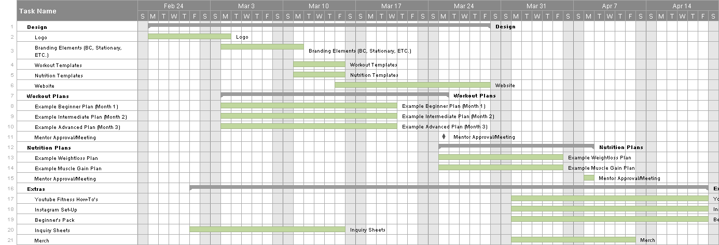**Gantt Chart:**